**[SniperGUI Manual]**

1. **General description of the Graphical User Interface (GUI)**This program is for marking cells to be isolated in a tissue. Marked cells can be isolated automatically using PHLI-seq instrument and SniperCellSorterGUI.py. Output files of SniperGUI.py are required in SniperCellSorterGUI.py for automatic isolation.

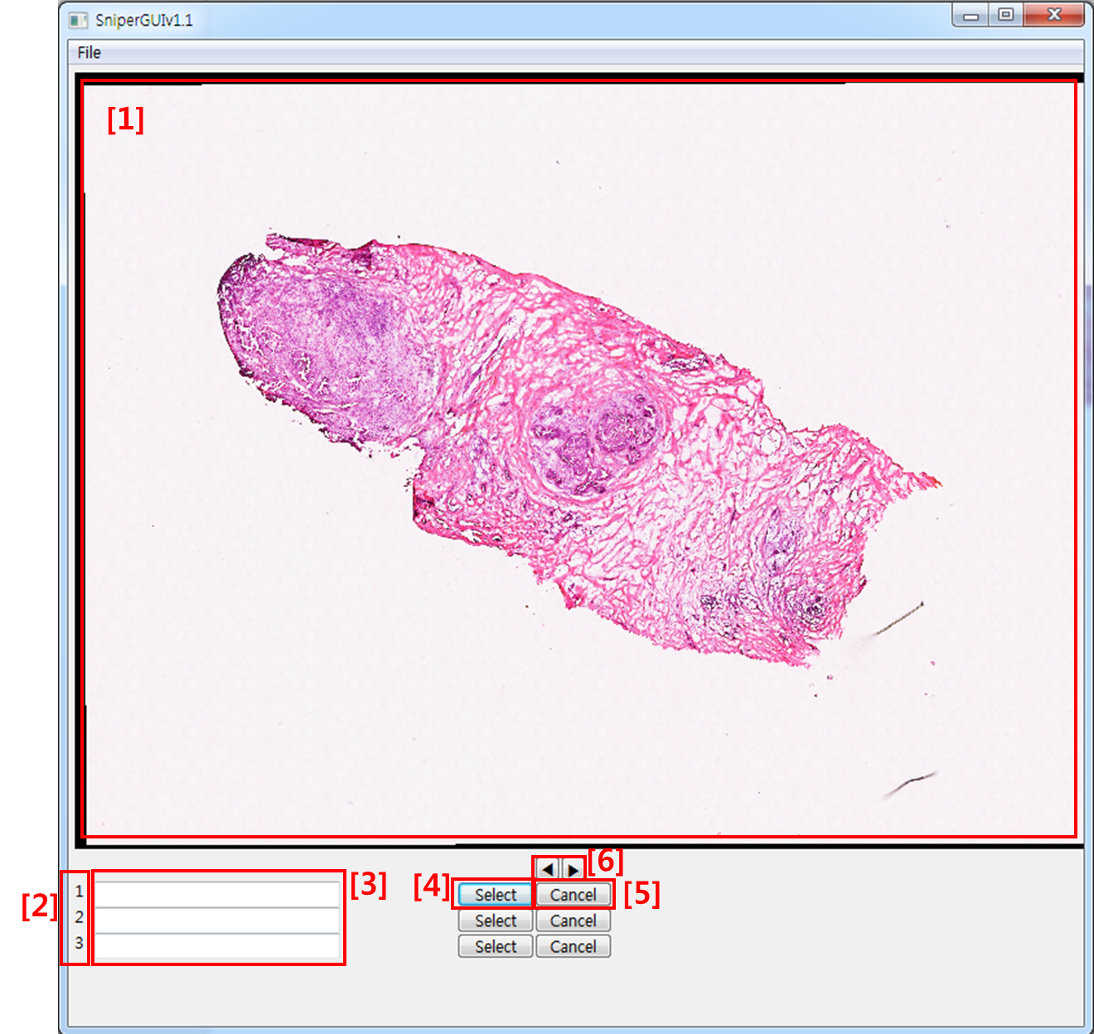

[1]: Image viewer

[2]: target index

[3]: description

[4]: target selection

[5]: cancel the selection

[6]: change index

1. **Image observation**
2. **Open image**

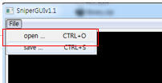

1. **Zoom in**: Ctrl + Mouse left click

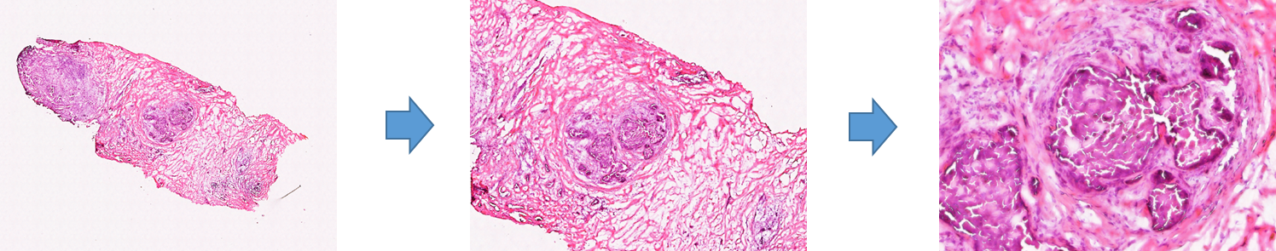

1. **Zoom out**: Ctrl + Mouse right click
2. **Move:** Mouse left click + drag
3. **Select targets**
4. **Select a region**: Mouse left click + shift + drag

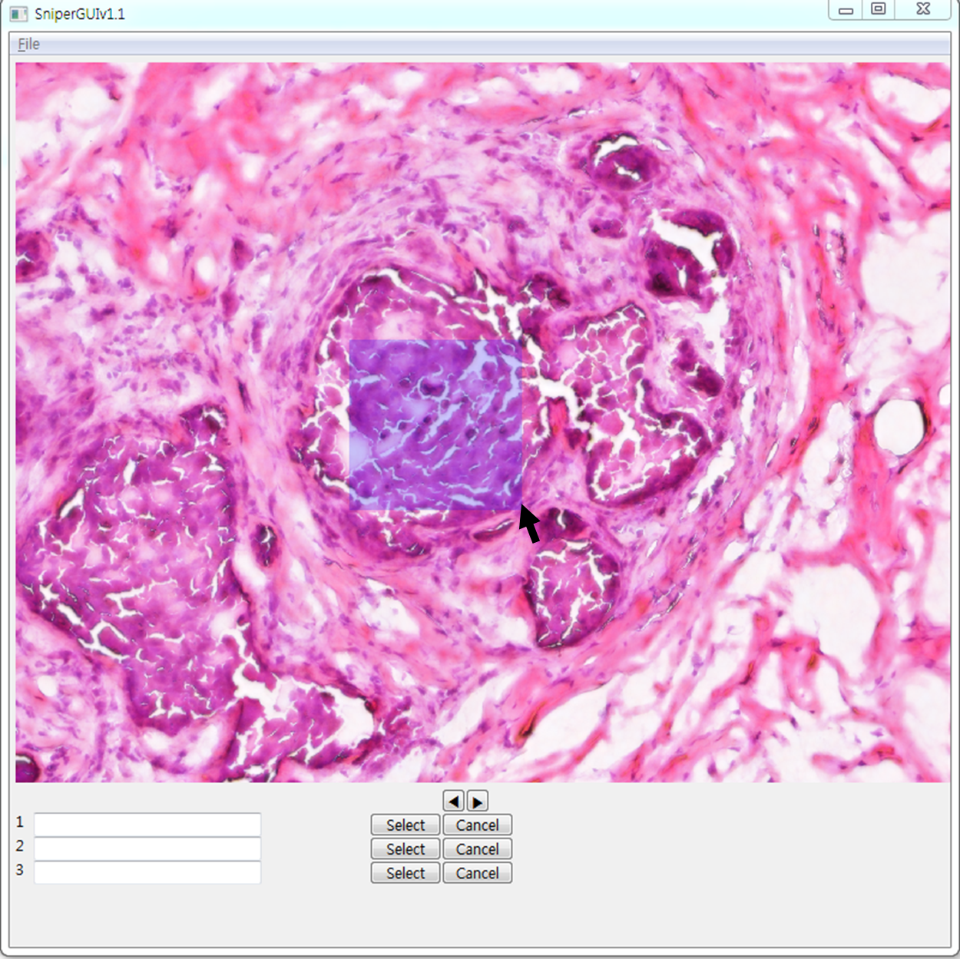

1. **Write description**

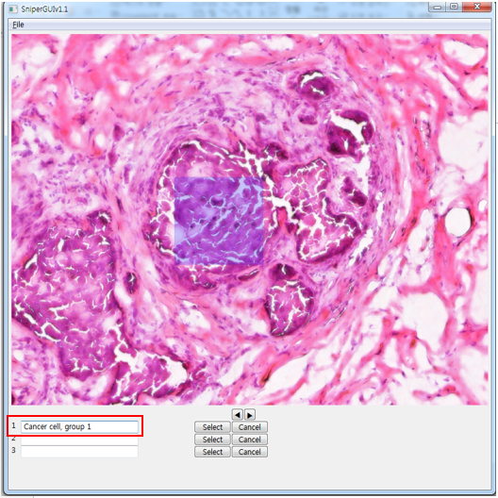

1. **Select target cells**

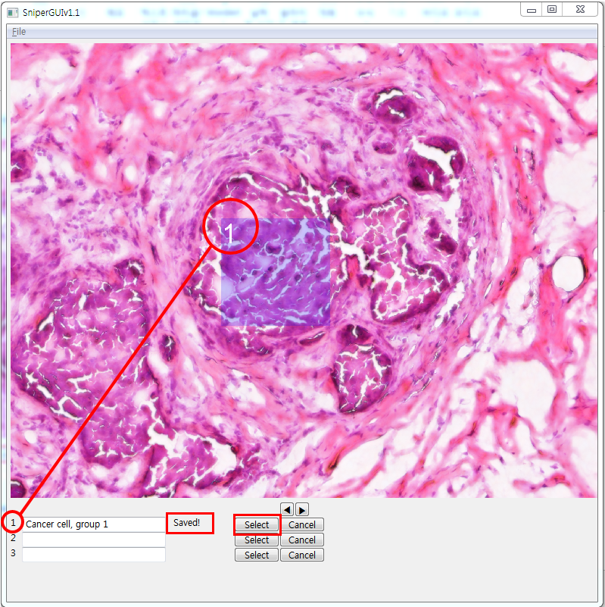

1. **Change Index**

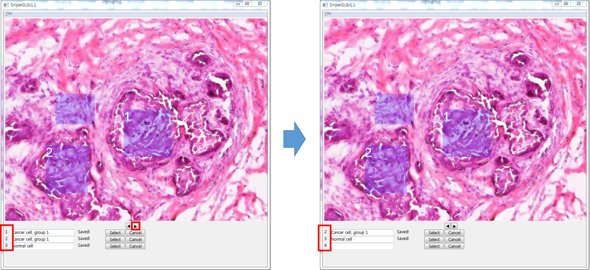

1. **Save data**
2. File > Save

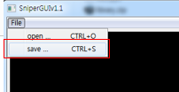

1. Output file creation

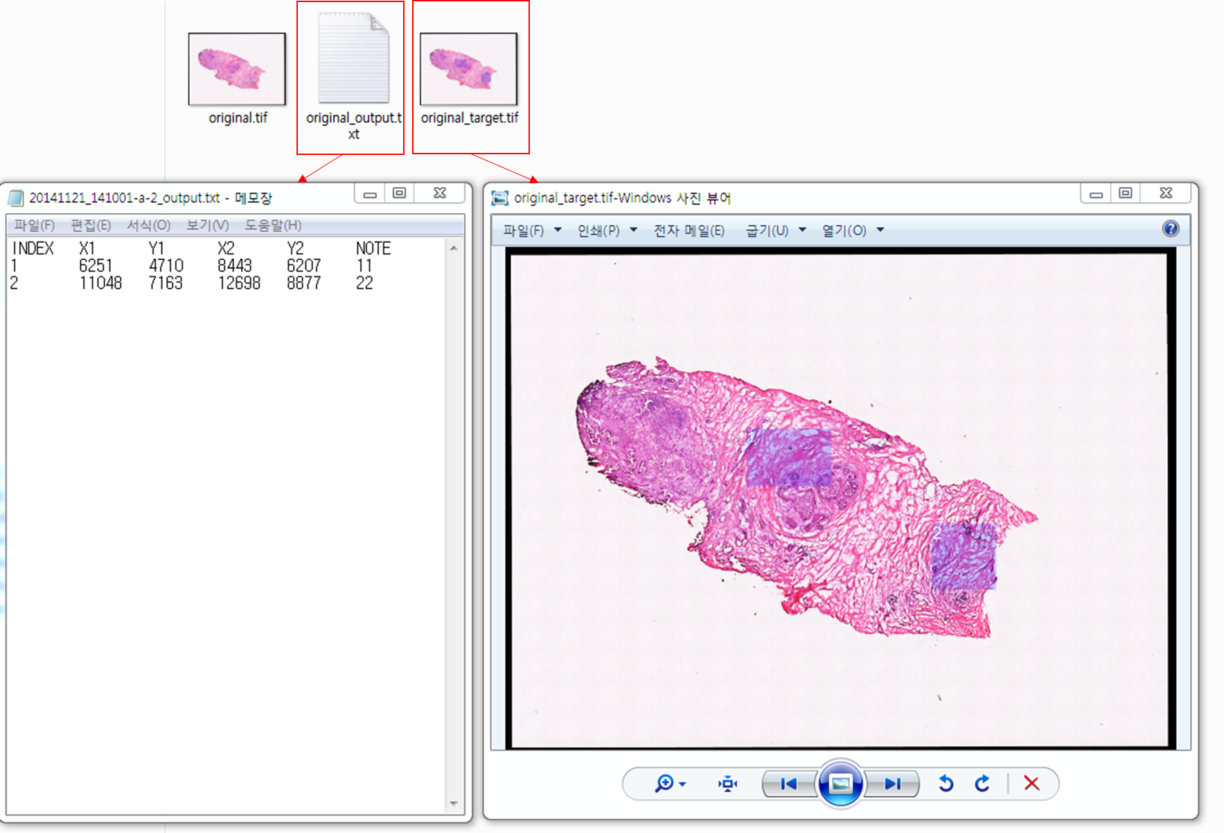

1. After saving, this program will generate *filename*_output.txt and *filename*_target.tif as output files. *filename*_output.txt contains locations and descriptions of the targeted cells on the image. *filename*_target.tif is an image file which will provide images of the targeted cells. These two files are required in SniperCellSorterGUI.py for automatic isolation.

Movie link: <http://youtu.be/VNk9LndnfnQ>

Questions: [amoslee89@gmail.com](mailto:amoslee89@gmail.com), +82-10-2700-0849